**Introduction:**

As thefts are increasing day by day security is becoming a major concern nowadays. In this project we will introduce to you the digital door lock system with keypad using Gizduino. This system will ask for a password before opening the door and opens the door only if the password matches the programmed key. The door lock is opened by servo motor which in turn is controlled by this security system.

**Objectives:**

The main objective of this project is to implement a Pass word Based Door Locking System using gizduino.

**Title and Description:**

Password based door lock system – Main concept behind this project is of a door-latch opening using a password entered through keypad. User can change this password anytime he/she wish using a keypad.

**Materials:**

* Servo motor
* 4x4 keypad
* Gizduino board
* Wires
* Buzzer
* Led

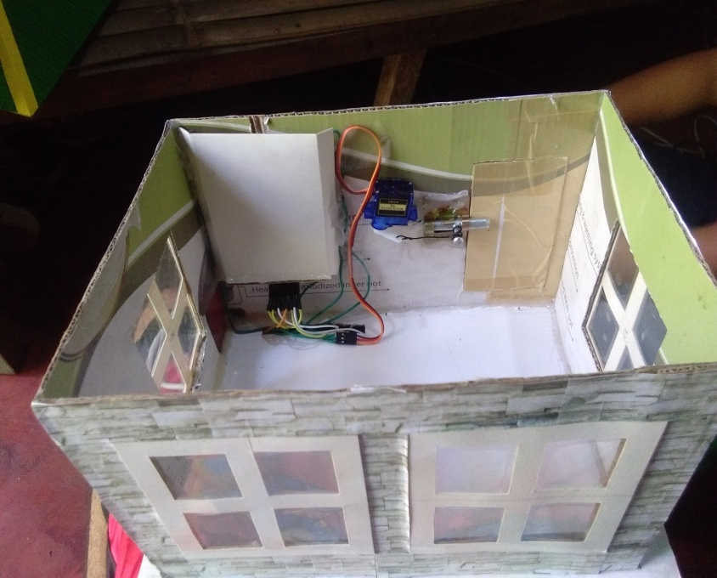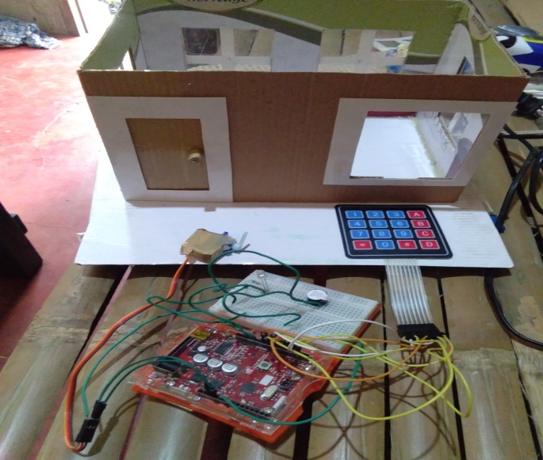**Hardware set up:**

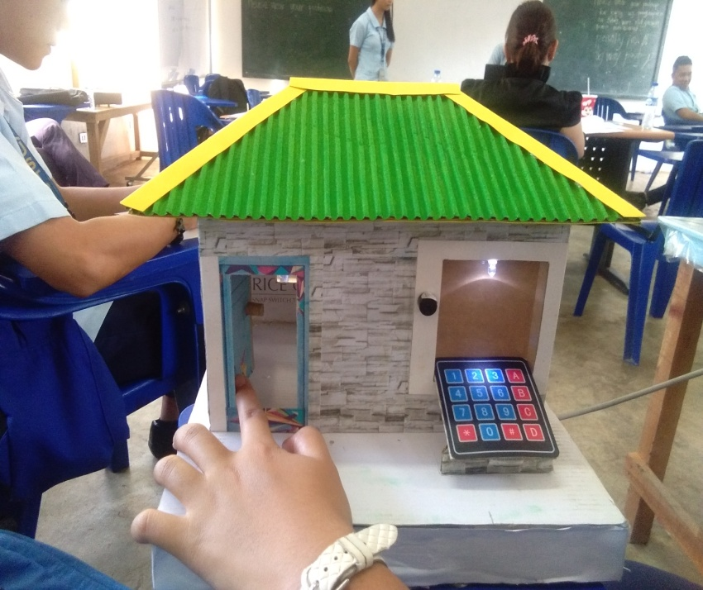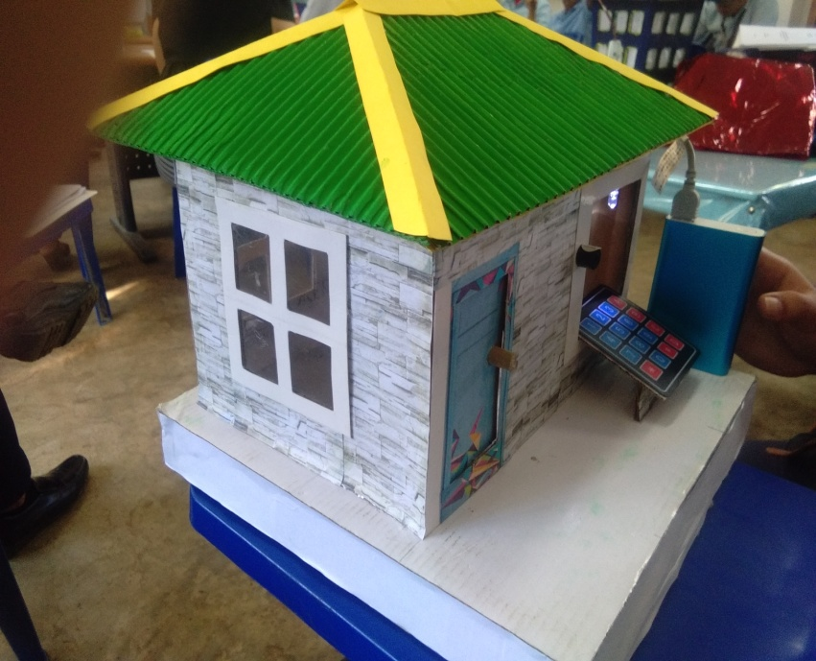

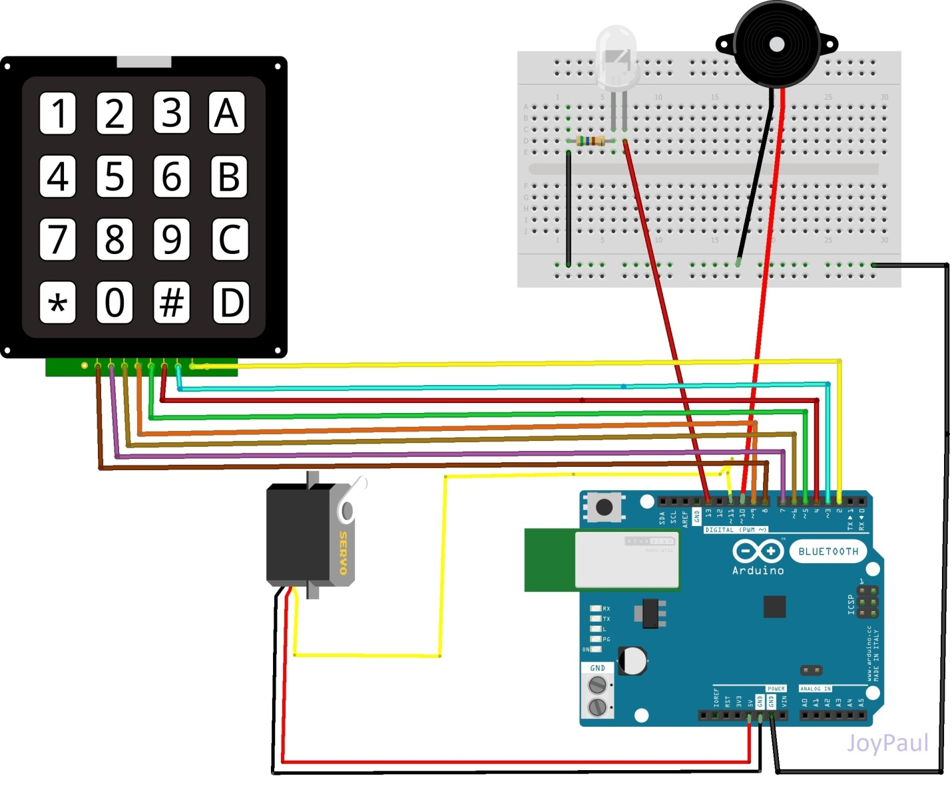**Diagram**

**Algorithm:**

1. Enter the password using the keypad
2. If the password entered matches the programmed key the latch will open by the servo motor.
3. The LED will turn on.

**Code:**

#include <Servo.h> //tells to use servo library

#include <Keypad.h> //tells to use keypad library

Servo ServoMotor;

char* password = "B6C01"; // change the password here, just pick any 4 numbers

int position = 0;

const byte ROWS = 4; //4 rows

const byte COLS = 4; //4 columns

//define the keymap

char keys[ROWS][COLS] = {

{'1','2','3','A'},

{'4','5','6','B'},

{'7','8','9','C'},

{'*','0','#','D'}

};

byte rowPins[ROWS] = { 8, 7, 6, 9 };

byte colPins[COLS] = { 5, 4, 3, 2 };

Keypad keypad = Keypad( makeKeymap(keys), rowPins, colPins, ROWS, COLS );

int RedpinLock = 12;

int GreenpinUnlock = 13;

int buzzer = 10; //buzzer pin

int led=13;

void setup()

{

ServoMotor.attach(11);

LockedPosition(true);

pinMode(buzzer, OUTPUT);

pinMode(led, OUTPUT);

}

void loop()

{

char key = keypad.getKey();

if (key == '*' || key == '#')

{

position = 0;

LockedPosition(true);

}

if (key == password[position])

{

position ++;

}

if (position == 6)

{

LockedPosition(false);

}

int position2 = 6;

if (key != password[position2])

{

tone(buzzer, 1000); //Send 1KHz sound signal...

delay(50); // ...for 1 sec

noTone(buzzer);

delay(100);

}

}

void LockedPosition(int locked)

{

if (locked)

{

digitalWrite(RedpinLock, HIGH);

digitalWrite(GreenpinUnlock, LOW);

ServoMotor.write(11);

}

else

{

digitalWrite(RedpinLock, LOW);

digitalWrite(GreenpinUnlock, HIGH);

digitalWrite(led, HIGH); // turn the LED ON (HIGH)

ServoMotor.write(90);

}

}

**Expected output:**

When the user inters the correct password the servo motor will pull the latch and then the user can now open the door. But when the user inters an invalid password the buzzer will beep.

**Learning Summary:**

The system comprises a number keypad and the keypads are connected to gizduino board. The gizduino continuously monitor the keypad and if somebody enters the password it will check the entered password with the password which was uploaded to the board and if they are the same then the board will switch on the corresponding device which is the servo motor. The system will allow the person who knows the password and it will not allow those who don’t know the password.

**References:**

<https://www.projectsof8051.com/password-based-door-locking-system/>

<https://www.google.com/search?q=learning+summary+for+password+based+door+lock+system&tbm=isch&tbo=u&source=univ&sa=X&ved=2ahUKEwjejq2EgZneAhVJWH0KHY75CjkQ7Al6BAgGEA0&biw=1517&bih=730#imgrc=_yUejf1KwQDc4M>:

<https://www.youtube.com/watch?v=CXPakz59WFc&t=412s>



**University of Science and Technology of Southern Philippines**

Alubijid|Cagayan de Oro|Claveria|Jasaan|Oroquieta|Panaon

Password Based Door Lock System

Sumitted By:

Caburnay, Paul David C.

Ebal, mary joy m.

Submitted to:

Engr. Diana l. Banawan

instructor